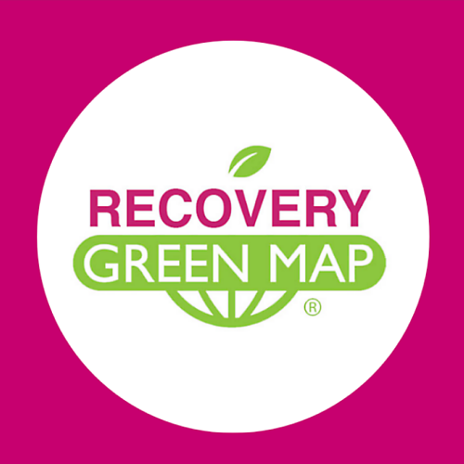 Recovery Icons DEFINITIONS
Use these icons on your maps, apps, murals, signs, social media and on our interactive mapping platform. See: GreenMap.org/recoveryicons
Contact Green Map System - info@greenmap.org
Tag yours #RecoveryIcons +CC
_____________________________________________

Public Health • food • medical • equity
Community Garden
Often planted on public or formerly abandoned land, community gardens are run by volunteers who cultivate flowers, herbs and vegetables, closer relationships to nature and one another. Sometimes fenced and locked or threatened by development, but generally open to all participants, raising the quality of life in the community, and improving air and soil quality at the same time. Offers hands-on learning and a habitat for birds and insects, too

Community Farm/ Coop Garden
Growing abundant fresh food is the focus. Increasing food security, coop farms also sequester carbon, build skills and relationships to one another and promote healthy eating. Seed saving, pollinator planting, permaculture and other regenerative practices are often included in these larger, cooperative farms.

Food Bank/Emergency Food
Food banks and emergency food distribution sites assure food is not wasted and hunger is reduced by providing low or no-cost food for persons facing emergencies, low-income or displaced people. These food security may serve meals, provide ingredients for home cooking or deliver to housebound people.

Food Gathering Site
Grow, pick and gather wild or cultivated edibles, glean fields and fruit trees, go fishing, or harvest wild herbs and foods. Consider ecological concerns, delicate habitats, health, and waste issues when using sites under this icon

Farmers Market/Local Market
Sells regionally grown produce. May be organic or traditional foods, sold in a lively permanent or temporary setting. Food does not travel far from where it’s grown, so it's fresh and nutritious. Shopping here directly supports small family farms, local economies and a greener countryside. May sell flowers, craft items, baked goods, honey, wine, wool, or regional cookbooks.

Testing Station
Place for health testing or monitoring. Can indicate medical offices, nonprofits, groups and websites, either permanent or set up during crisis situations.

Critical Supplies
Material goods that cover basic needs and the most important supplies in a time of crisis.

Hospital
Building or temporarily designated space where emergency, surgery or other critically-needed health care can be obtained.

Wellness Resource/Alternative Health
Place to receive health and wellness care outside of mainstream medical practice. Yoga, massage therapy, holistic, herbal and traditional Chinese medicine represent a few examples of wellness resources that spur recovery. Seek certified practitioners.

Unhealthy Spot / Quarantine
Officially recognized or well-known site where residents' health has been threatened by disaster, disease, emissions, environmental degradation or unjust practices.

Wash Hands Here
Wash and refresh here. Icon can be used to indicate hand washing stations and may provide drinking water, a comfort station, or information on water purity and conservation.

Volunteer Site/Coordinator
Place where you can offer a helping hand. Volunteer work can be undertaken by almost anyone and contribute greatly to community wellbeing. Contact coordinators for training, tools etc. Parks, hospitals, theaters, schools, service learning programs are just a few of the places that thrive thanks to volunteers.

Readiness / Recovery Superhero
Group (or person) that has carried out oustanding work in the face of danger from pandemic, natural disaster, blackout, fire, civil or other disruption. The Superhero has great foresight.
Social Service
Provides resources to help people in need. May include 'green collar' job training, charity, welfare agencies, advocacy, food assistance or health programs. Some social services are run voluntarily by community groups, others by religious, governmental and non-profit organizations (NGOs).

Translation/Interpreter
Language support that enhances participation and access to services by all people.

Temporary Housing
In times of disruption, whether acute or chronic, this place can provide or help to locate shelter.

RELAX • design • nature • culture

Physical Distance Design
Space planning and design (permanent or temporary) that encourages people to physically separate themselves.

Mask Up - Crowded Place
This area may be too crowded for physically distancing from others. Wear your mask and be cautious and considerate, or move on to a less crowded area.

Community Collaboration
Teamwork makes the dream work! Pitch in on climate change, social justice, regenerative and green projects here. Community Collaboration hubs can be informal or formal, volunteer or bottom up, in person or online.

Bird and Wildlife Watching
Public place to view animals in the wild (even the urban wild). Officially recognized or locally-known sites may have a nature center or interpretation with guidelines for viewing without harm, and details on the species you might see. Avoid exposing delicate nesting areas or endangered habitats.

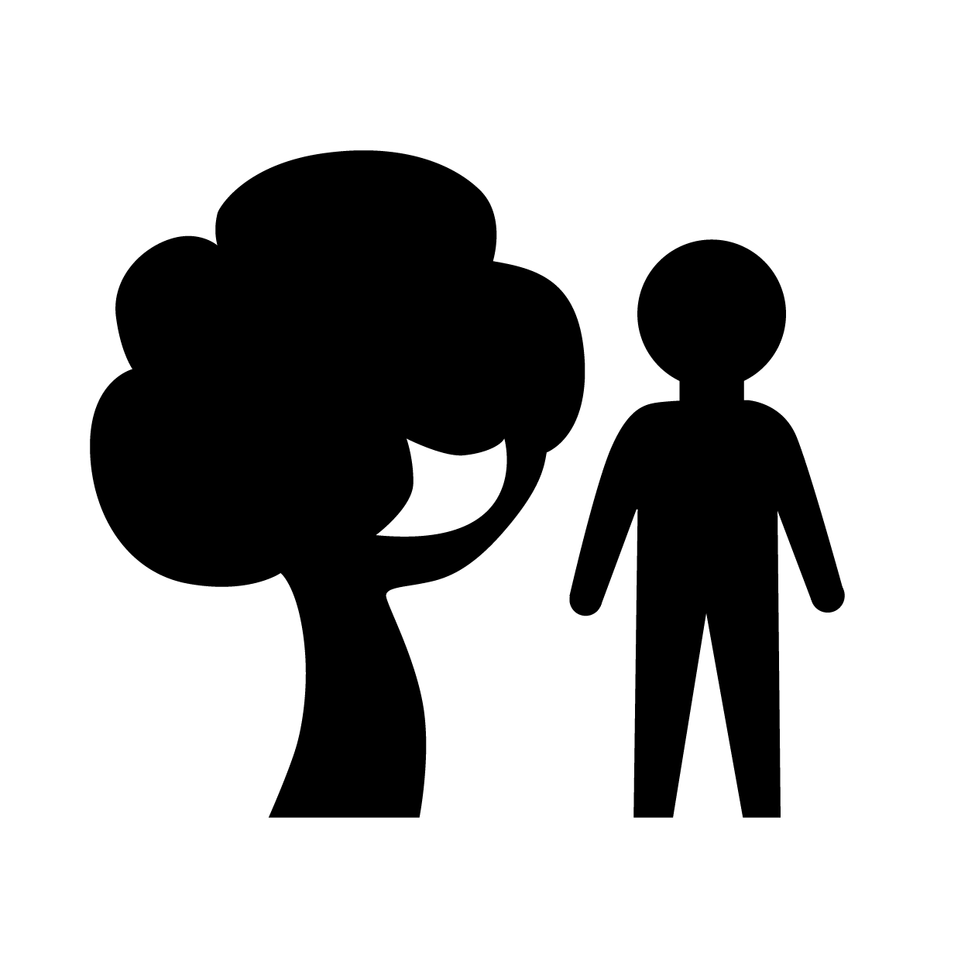Park - Open Space/ Eco Active Area
Green space that offers a place to relax and play outdoors. May include picnicking, sports fields, running paths, canoe rental, or workout/play equipment, along with diverse vegetation and a pond, creek or other water feature. Not all parklands are publicly-owned and free. Preview your Parks Department website online for current offerings.

Cool Spot
Chill out here! Healthy, cool and free spots help the public preserve personal comfort while reducing home energy use. Sites can include public libraries, courtyards, shady green spaces and other sites.

Lively Spot
Site of social gatherings and fun cultural activities indoors or out, or even online. May include a streetscape, special park, campus, community hang out spot or online meeting place.

Culture without Crowding
With safety in mind, cultural events are taking place in new venues and places. This icon designates places where you can be physically distant but enjoy art, music, performance, and other cultural events and spaces.

Outdoor Dining
Enjoy a meal, drinks or snack in an outdoor cafe, food truck area or picnic zone. Can be temporary cafe seating or ongoing location designed for physical distancing.

Eco-spiritual Site
Place to safely contemplate nature or spiritual pursuit. May be a community wide, environmental or religious sanctuary, a profoundly beautiful place, even an old cemetery or an 'oasis of calm' in a busy area.
Traditional / Indigenous Culture
May refer to indigenous, pioneer or migrated people’s traditions. Might be a settlement or ethnic enclave that is not assimilated into the prevailing culture. May include library or museum resources for understanding people living in traditional, more ecological or self-sufficient ways.

REGENERATE • work • everyday • utility

Resilience Training/Development
Resilience features including green and reused infrastructure, rain gardens, green roofs and other interventions, whether community-built or a public work, generate employment opportunities. Find development, planning and training programs of all descriptions, from engineering and design schools to youth stewardship projects, at these sites.

Employment/Business Support
Get trained for various types of recovery, regenerative culture, green employment and sustainability work here, including new fields opening up in the era of Corona recovery. This icon can indicate support resources for any kind of local business, especially to help them pivot to address the new workplace reality including training, counseling, coaching, financial support, legal and more will help retain employees and keep businesses in business.

Local Business
An economic enterprise solely based within the community, not a national franchise or chain store. Locally owned and managed, but not necessarily a green business. Needs local support! Re-circulates money within the local economy and often sources goods and materials nearby, reducing the ecological impacts associated with shipping.

Social Enterprise / Co-op Business
A place where people work together to make a living and to benefit society, the environment and our common future. May be a coop, coworking, makerspace, residence, service or business. Eco-villages, communal projects, cultural commons, shared mobility, food, energy, specialized materials, and DIY rapid response and open source projects could be included here.

Green Tech / Green New Deal
Renewable, alternative or other sustainable technology sites that may fall under 'Green New Deal' and related principles. May include clean technologies, zero emission, biomass and clean energy generation, new and appropriate technology sites. Stewardship, low-tech initiatives, citizen science, pilot projects, related agencies and funding sources, etc.

Pedestrianized Street
Streets generally without cars, cleared for pedestrians, full or part time. Wider than sidewalks, pedestrianized streets contribute to wellbeing and conviviality, especially with shady trees, benches and other street furniture. Such streets extend zones for safe physical distance walking.

Bicycle Site
Generally used where you might buy, borrow, repair or rent bicycles, work bikes and other kinds of human-powered vehicles. Can indicate bicycling organizations of all kinds, bike-friendly services, infrastructure and sites.

Farm with Animals
City farms, demonstration farms, gardens with chickens and rabbits, police horse barns, and other places where the public can see domesticated animals carefully tended, ethically cared for and sustainably raised. Purchasing directly from these sites (in person or online) can help sustain the farmers and provide high quality food.

Mutual Aid
Sharing direct aid and supporting inclusive recovery and advancement. Networks often have an active online community working behind the scenes during disruptions and crises to ensure food security, mental health support, delivering critical supplies, etc.

Public Restroom
Public Restroom which is likely to be clean and safe. May be temporary, or closed part time. Not likely to be an example of green technology.

Wifi Spot
Wireless internet connection area that offers free public wifi in parks, libraries, on curbside kiosks, etc, rather at commercial sites. Do be aware of internet safety when using free wifi services.

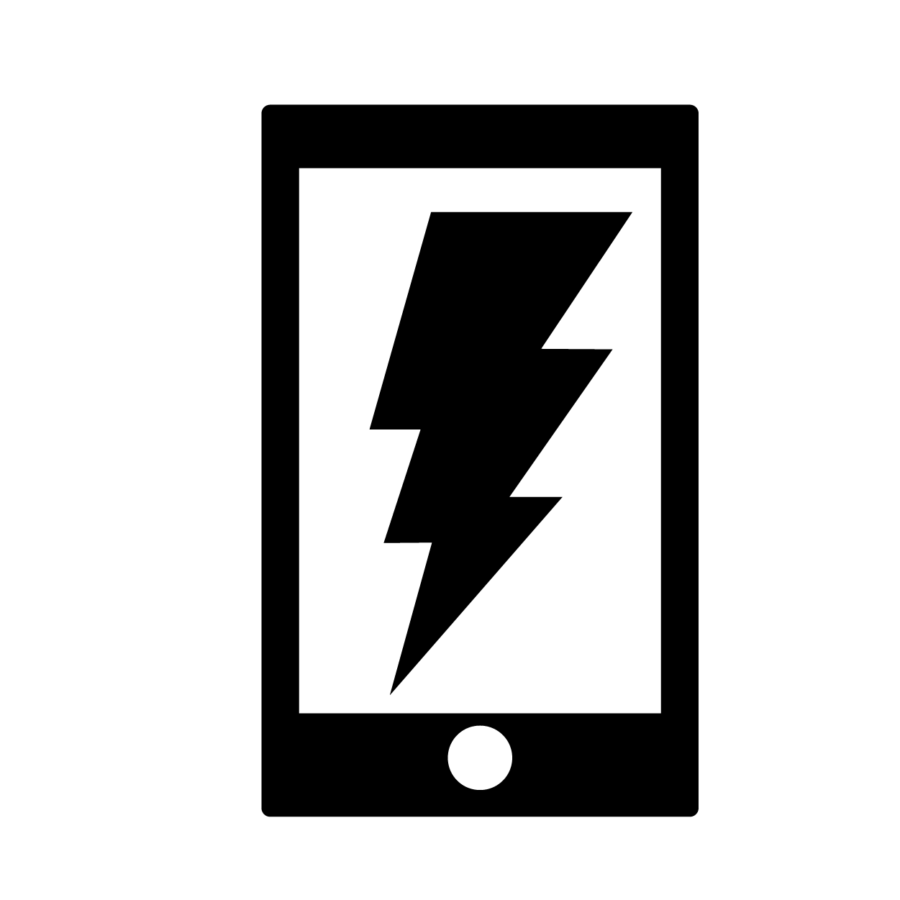Public Charging Station
Place to charge phones, and may have capacity to charge laptops, eBikes, wheelchairs. May be solar powered or grid tied, often located in a public space, and free to use.

